This chapter focuses on chemicals used for cleaning in the house, principally considered the responsibility of women, though of course this is not the case for all households. Soaps and detergents for textiles have tended to capture the limelight, partly due to their connection to the durable technologies of laundry and for their attractive advertising and packaging which has facilitated the collection of historic materials. Instead of treading that ground again, I intend to examine several other scenarios. Relating to the work on laundry, I want to examine options other than conventional laundering for removing grease marks from garments and other textiles. Looking beyond laundering to other dirty jobs, the oven and the toilet provide two more specialised surfaces to be cleaned. Regarded as unpleasant, tough, tedious tasks, household chemicals and branded products have been readily employed to aid the performance of these aspects of housework.

Household manuals, home economics texts and advice columns in magazines and newspapers, along with product advertisements comprise my initial sources. These types of source occupy authoritative positions from which practices believed to be effective were disseminated widely among those who undertook (or perhaps supervised) the cleaning. An additional resource are user surveys and other material gathered by advertising agencies as part of market research and understanding the potential users of branded products. These sources could alternatively be described as what people should do and what people say they do. To complement these, I will include another version of self reporting, by incorporating the reflections of people interviewed for this thesis who bought and used such products.

Concern about the misuse of household chemicals has been longstanding. E.T. Neathercoat, a former president of the Pharmaceutical Society of Great Britain, opined 'However drastic our poison regulations they will never be fool-proof'. The impetus for this was the Poisons Law newly enacted in 1926 which prevented poisons being sold by chemists unless they were clearly labelled as such. He welcomed the sentiment behind improved labelling, but worried about the 'ignorance and carelessness' of users, of the 'despairing' and about 'inquisitive children'. His concern lay chiefly with acids: carbolic, oxalic, hydrochloric (spirits of salts), (salts of lemon), sulphuric, nitric and (vitriol). He expressed a view that was published surprisingly rarely, that 'If effective for the purposes for which they are sold, all of them are virulent poisons of causing an agonising death'. Other than suicidal users, Neathercoat did not mention other forms of deliberate misuse despite the high profile (if not frequency) of acid attacks.

Unspecified soda was recommended very frequently in household manuals such as Mrs Beeton, as well as in housework advice columns reproduced in newspapers. This lack of specification required those undertaking the housework to know that it was washing soda, or sodium carbonate which was referred to. By making up different strength washing soda solutions and by using soda water at different temperatures, soda was made to shoulder the bulk of domestic cleaning work, from cleaning pans and cookers, saving soap by softening water, floors and other surfaces as well as the brushes, cloths and sponges used to clean them, clearing blocked drains. However, by editions produced in the 1980s these recommendations had ceased and been replaced by suggestions to use detergents and specialised (but unnamed) proprietary products. The incidence of recommendation, whether in columns or books gives an indication that the experience of using chemical aids in housework had altered over time. In fact, these newer editions of Mrs Beeton may have been somewhat out of touch, as since the 1970s advice and books about housework demonstrated a renewed interest in washing soda as a frugal alternative to convenient preparations in economically difficult times, then as an environmentally friendly option, so long as the energy costs of producing it were ignored. This was the case apart from when the company promoting the 'greenness' of washing soda was the multinational corporation ICI, in which case the statement was a red flag to the environmental organisation Friends of the Earth.

Case Study
Soda

The manufacture of soda ash is the basis for the industrial production of all the sodas discussed in this chapter. Soda ash requires common salt and limestone as raw materials. Although soda ash was historically produced by the Leblanc method, the Solvay method also known as the ammoniated brine process, was the principal means of production between the 1930s and the 1980s, and is still in use today. This process was developed in the 1860s by Brunner Mond who built a large plant in Winnington, Cheshire, making use of the natural salt deposits in that geographical area which could be extracted as brine. During the process, brine was mixed with carbon dioxide generated from the heating of limestone. To ensure a supply of limestone for soda ash production, Brunner Mond acquired shares in the Buxton Lime Firm, Derbyshire and that company became part of ICI in 1926, forming the foundation of the Lime Division. Business historian Charles Wilson suggested that British soap firms were concentrated in the North West in order that they could be situated near the salt deposits that generated the caustic soda they needed. There were soda plants elsewhere, such as Thawpit's in High Wycombe, which as well as being a recognisable brand of household chemicals in their own right, also supplied Boots the Chemist shops with loose, unbranded soda.

Soda ash, caustic soda, soda crystals and bicarbonate of soda were the most important products made by ICI's Alkali Division, and while the domestic consumer was considered, at least for washing soda, the destination for the bulk of these products was industry. Business historian Charles Wilson suggested that British soap firms were concentrated in the North West in order that they could be situated near the salt deposits that generated the caustic soda they needed. There were soda plants elsewhere, such as Thawpit's in High Wycombe, which as well as being a recognisable brand of household chemicals in their own right, also supplied Boots the Chemist shops with loose soda.

In 1950, ICI produced a report which listed their main competitors in the production of caustic soda to be Murgatroyd's Salt & Chemical Co. and the Staveley Iron and Chemical Co. On the subject of soda crystals, they named East Lancashire Chemical Co., B.Hepworth & Co., J Manger & Son, Thawpit, and J. Bailey and Co. The object of this exercise was to illustrate ICI's competitors and emphasise that ICI did not have a monopoly, however the report did not include production or retail figures leaving readers no wiser as to how strong these competitors were, only that they existed.

Caustic soda
Caustic soda was manufactured by the lime-soda process, where the soda ash was combined with calcium hydroxide (slaked lime). Sodium hydroxide is also known as lye, or caustic soda. It is not the same as lunar caustic, which is silver nitrate. Caustic soda was made by Joseph Crosfield and Sons, Warrington as part of Unilever, until 1939, when they handed over manufacture to their parent company, while retaining the sales of the product. Despite being a minor part of their operation at that site, the closure of the plant affected around 100 workers. Sodium hydroxide is a strong base, or alkali, it can cause burns to living tissues if not neutralised or rinsed off immediately. This requires care to be exercised in its domestic use. Sources on caustic soda are concerned with reporting its industrial production or manufacturing uses, including company doctors sharing information on treating factory accidents, or news of workplace accidents, rather than the domestic uses. Where use at home is mentioned in professional publications, it has tended to be in relation to accidents, especially fatal poisoning by ingestion. Although it burns in the mouth, in practice this sensation does not always lead to it being spat out, as a reflex swallow is the alternative response with dire consequences. The danger of caustic soda in the domestic environment had been long known, and household advice from 1843 had advised never to keep "vitriol, soda, nor pearl ash" in the kitchen, due to their potential for injury both to the user and the object it was being used on.
This danger of poisoning appears to have been well heeded, at least at during the period that this thesis is concerned with as the number of fatal accidental poisonings occurring in the British home was low for caustic soda. It was responsible for 7 deaths in children under 10 years old between 1931 and 1935, with the chemical being classed as a "corrosive", joining cresol, phenol and unspecified acids to kill a total of 16 children between 1958 and 1977. These figures also show a decreased prevalence of poisoning with caustic soda, indicating perhaps that its presence in the home diminished over this period. Accidents were sometimes reported in newspapers, such as when a twelve-month old child picked up caustic soda flakes that his older sister had placed on the table and put them to his mouth. When accidents reported like this, people could imagine a similar accident happening in their household, so dissemination of stories of how these chemicals had been misused could have a preventative effect.
As well as degreasing surfaces and clogged pipes, caustic soda could be used to remove old paint, and although there were paint strippers available, it was a good option for those followers of furniture fashion who already had it at home. Wearing rubber gloves was suggested for both caustic soda and dedicated paint strippers, a precaution extended to spraying trees with winter wash, which consisted of a strong solution of caustic soda. Another use suggested by a gardener was that it could be used to help remove oak tree stumps. The letters page was regularly used for sharing advice about the use of household chemicals for various tasks.
Caustic soda could be used for harm, as an alkaline form of the more conventional acid attack, following the typical pattern of a spurned lover attacking the object of their desire, or as detailed in a report on a clash between police and anti-racism protestors following a National Front march in Lewisham, 1977.
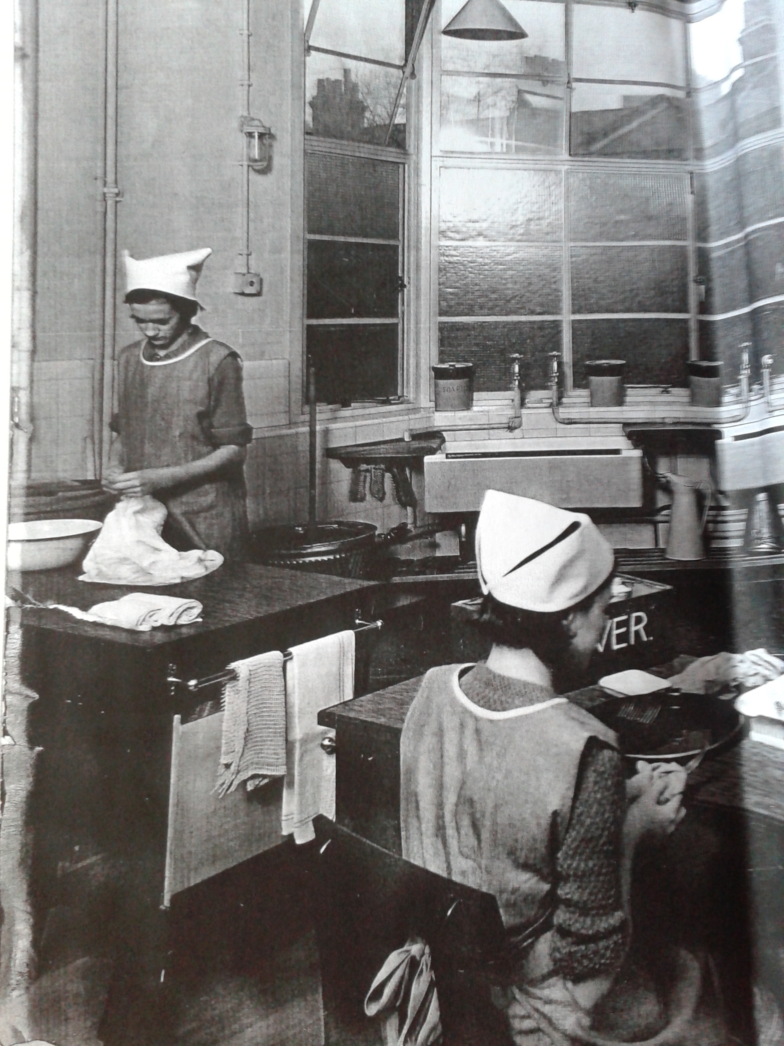Illustration 1: Scene from a home economics class at the West Kensington Central School, 1930s, where on the windowsill are three large containers. The one on the right hand side is labelled "SODA" Institute of Education Archives, Newsam Library, BF1/1/33
Stricter controls on the sale of caustic soda were suggested in 1935, at a meeting of the British Association of Chemists, in a discussion on the control of poisons.
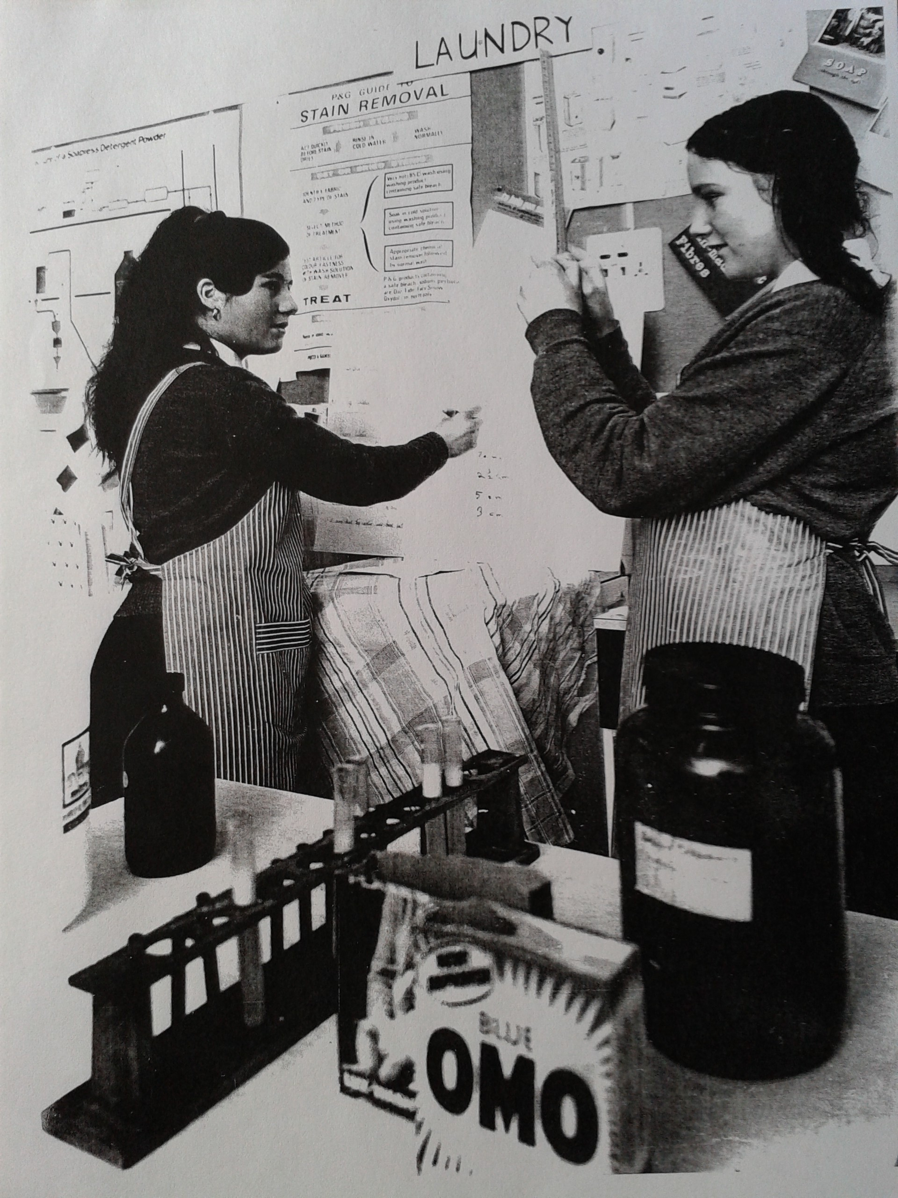Illustration 2: During a home economics lesson at St Richard of Chichester School (1968), two pupils conduct an experiment into the amount of foam detergents produce in relation to water hardness. Pinned on the board behind them is a poster "The P&G [Proctor & Gamble] guide to stain removal" Institute of Education Archives, Newsam Library, BF/1/1/29, 66/10534

Washing soda is...
Sodium carbonate

Described by Reeves as popular with working class women before WWI because as it was cheap, it was "made to do a great deal" including children's baths and hair washing. From Reeves we see the kind of quantities that women would buy were large, 7 pounds at a time was regular and 3d was a usual price for this amount.

Buying cheap washing soda could be perilous, as the causticity could be higher than expected and cause problems such as the example Reeves gave of a woman who "scrubbed and washed and

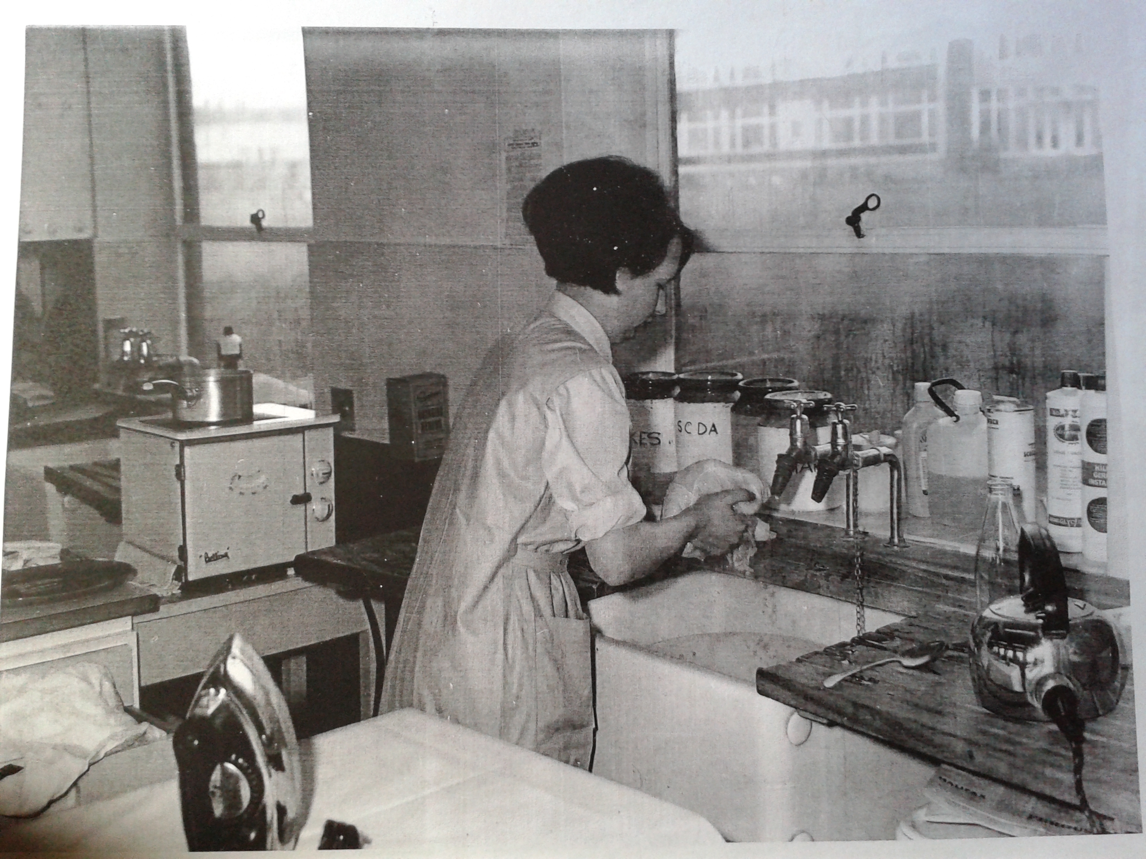Illustration 3: Home economics class at Kidbrooke School, 1966. Large jar on the windowsill labelled "SODA" Institute of Education Archives, Newsam Library BF/1/1/19 (a)

cleaned with it until her arms lost all their skin and she was taken into the workhouse infirmary with dangerous blood poisoning".

Very often no precise measurement was given for the amount of soda to be used, nor were any ratios given for the volume of crystals with respect to the volume of solvent. The crystals were generally to be dissolved in warm or hot water, though sometimes other substances such as milk when the solution was destined to clean leathers. Descriptions such as "a little soda" abound, meaning that each person's experience depended on their personal interpretation of the instruction. Sometimes more precise detail was provided about the amount which should be used for successful results, as in these examples where the lump of washing soda was described as "about the size of a sixpenny piece", or "about the size of a walnut". Good results were therefore very closely linked to the experience and knowledge of the user.

Perhaps unsurprisingly when the potential for variability in strength of soda solution is considered, soda acquired a reputation for being harsh on hair, skin and fabrics. The advertisement of goods, such as the laundry soap Sylvan flakes as specifically not containing soda illustrates this.

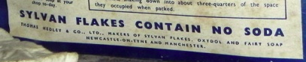Illustration 4: Sylvan soap flakes – every box bore this declaration that they do not contain soda.

Washing soda's ability to soften water was a major reason for its use, and would explain any potential variation in uptake in different areas, as water hardness is intrinsic to geography with hard water resulting from water percolating through chalky deposits in the East and South East. Water hardness causes regionalised problems such as limescale deposits on toilets, kettles, taps and shower heads, in turn leading chemical users to prefer for certain brands of cleansers, detergents and even tea bags.

Using washing soda was not a passive activity, it had to be dissolved, then the resulting soda water would be used to scrub. Scrubbing with soda water yielded 'snow white' toilet, kept slime from developing on wooden draining boards (replaced by less demanding materials). While Elizabeth Roberts recorded women talking about the competitiveness of their mothers regarding getting the toilet board white, in J. Brian Curzon's study of toilets how the always clean, albeit dark and spidery places got clean appeared to be a complete mystery. Whether this difference resulted from the material being researched from a male perspective, focused on the mechanical technologies, or tapping childhood memories of people who were blissfully unaware of the efforts of housework, is unclear but the difference between the results of two authors talking to people is striking.

While washing soda could be, and was one of many household chemicals used to clean toilet bowls, it was displaced by branded, ostensibly dedicated (rather than multipurpose) products not based on washing soda. Harpic, which we shall examine in more detail was acid sodium sulphate, and when dissolved in the toilet bowl it gave a solution of sulphuric acid. This was particularly effective at removing limescale, which dulled the porcelain bowl and provided a rough surface for dirt to cling to. By removing the limescale, the acid was more effective than bleach which might temporarily whiten the dingy finish but would not solve the problem of limescale and dirt's affinity for it. This information was not related to the user in adverts, which did not mention Harpic's relationship to the dangerous sounding sulphuric acid, or even its particular action on limescale, only that it reaches into the bend where the toilet brush cannot and that simply leaving it to work will result in a glistening, deodorised and disinfected toilet bowl. That in 1966 the constituents and actions of the cleaner were explained by manufacturers Reckitt & Sons to the advertising agency JWT in a confidential letter suggests that the general public were very much in the dark about the nature of the product.

Harpic was introduced to the market in 1921 by the Harpic Co., initially selling the powder in unsuitable cardboard cylinders which were degraded by the acid product. This was quickly rectified by using metal cannisters instead. In 1924, Reckitt's & Sons attempted to purchase the company, but considered the asking price too high. Harpic Co. changed the lid to a sprinkler in 1925, to control the flow of the powder and appear less wasteful. By 1932, Reckitt development chemists had reverse engineered a potential competitor which placed the company in a position to negotiate a more appealing price to buy Harpic Co. For the entire duration of the period this thesis is concerned with, the 1930s to the 1980s, Harpic has been owned by Reckitt's & Sons, later Reckitt's & Colman and has been a staple product in the domestic bathroom. Harpic advertising changed very little between the 1930s and the 1980s, the highly focused campaigns concentrated on toilet bowl cleanliness. This specificity was directly related to the chemical composition of Harpic, the acidity of the which rendered it suitable only for cleaning 'lavatories, or other porcelain or vitreous china articles'.

Harpic was advertised extensively in Good Housekeeping magazine and daily newspapers such as the Daily Herald. Penguin books had been suggested in 1937 by Reckitt's & Sons as a vehicle for Harpic adverts, but dismissed by their advertising agency JWT as not reaching the right audience, as well as expensive. While the accompanying images and exact text varied a little, the adverts always informed the user what to expect a 'glistening' 'shining' 'scrupulously clean' 'safer than ever' toilet bowl, to use Harpic daily, while emphasising that it was easy and fast to use. In 1950 perfume was added, though existing users were reassured that they could still get the 'familiar kind'. Safety of the product user was not mentioned, the manicured hand holding the cannister was not sheathed in a rubber glove, but the safety of the porcelain and the future safety of bathroom users through the disinfectant properties of Harpic were noted. This prioritisation of the effectiveness over the safety of the chemical is not surprising for the 1930s to the 1960s, but the sentiment remained into the 1980s. The user imagined by Reckitt was the housewife, explicitly stated in 1940, suggested by a feminine hand and the notion of one person in charge of enforcing standards and shopping. The delicate hand disappeared in 1955 in favour of a beefcake symbolising strength, but it was unlikely that the work would be expected to have be done by a man. A staple feature of the adverts was a technical cross section illustration of a toilet, showing the S-bend that other products left unclean.

While schoolboys might not be the usual audience for toilet cleaner advertising they had certainly picked up the gist, when the brand name became an unkind nickname for comedian Simon Fanshaw's teacher 'We called him Harpic for the simple reason he drove you clean round the bend'. By the 1980s, Harpic was very much a household name in Britain, and used as shorthand for disinfectant or indeed almost any cleaning product, rather than any great understanding of its properties or best uses. The smell was evoked when tasting unpleasant foods, and when describing a not very good wine 'Jacob's Creek … could to be to wine what Harpic is to toilets'.

Writer Robert Nye recalled his mother in the 1950s wiping down books from the public library with a handkerchief rubbed in Harpic. This snapshot of Mrs Nye who, at least in the eyes of her son, used Harpic not only for cleaning her home in the conventional methods, but also in a way that she believed protected her home, and the people within it, from germs from unknown people and their potentially grimy homes that could be borne by the library book.

Whenever Reckitt & Colman were mentioned in media reports of the company's activities, Harpic was routinely given as an example of one of their products that readers would recognise. Harpic was deemed an anomaly, along with the company's other household cleaning products like Brasso and Windolene, that went against economic theorists' predictions for product life-cycles as it continued to sell well from the 1930s into the 1980s. What these economic theorists perhaps did not take into account was Reckitt's commitment to understanding their product users. Their choice of advertising agency, JWT, had a well established research department, and by the 1950s Reckitt & Colman had one of the few industrial market research units. Users and non-users were surveyed extensively, considering age, family composition, economic status, housekeeping habits and where applicable which competitor or alternative products were used instead of Harpic and why. When they recruited for the Commercial Research Department in 1964, the department was described as having its own nation-wide team of interviewers and modern data processing equipment. This systematic, strategic, modern Market Research Supervisors were advertised for using the feminine pronouns 'she' and 'her', that for this 'challenging' position they should be willing to travel the country in the provided company car, design questionnaires, interview respondents and train other interviewers. The gendered specification indicates that Reckitt's valued women's communicative ability to draw out useful information from housewives. Their advert for a market research officer displayed hopes for a university graduate with relevant experience in a research agency or manufacturer, with the aim of developing new research techniques. The first word in that advert was "He", indicating that the innovative, important work with good promotional prospects was deemed more suitable for a man.

However the research unit was composed, this connection with their users allowed Reckitt's to develop and market a range of household chemical products that were very well received.

Caustic | Washing | Bicarbonate
Winter wash for trees | Mixed with copper sulphate to defend against potato blight or as a treatment for plant rust, which specifically troubled snapdragons | Fire extinguisher
Killing tree stumps, including oak | Washing soda placed on the cut root of a dandelion would kill it
Caustic soda could be used to remove old paint from furniture, | Bed-bug infestation - beds should be be dismantled and scrubbed with soap and soda.
caustic soda can be used to neutralise acid from the "wireless accumulator" to stop it burning a hole in the carpet | weak solution of washing soda can be used to soothe sore eyes from over-chlorinated swimming pools.
Violent chemical attack | Soften water, save soap
 | Slow coal burning, save fuel
 | Clean oven, save fuel
 | washing soda to neutralise burns from acid. | baking soda for scalds and burns from fire
 | To remove the smoke stains underneath mantlepiece, pumice stone, whiting and powdered washing soda are mixed to a paste.
Table 1: Domestic uses of sodas

Soda in wartime
In October 1940, ICI announced that they were withdrawing from sale their "special moisture-proof packages" of washing soda, as the material was urgently needed for other uses, and informed consumers that despite the "familiar blue and white packets" disappearing, the product would still be available loose. This action was in response to the paper control order issued in February that year, to reduce the amount of paper used to package commodities.

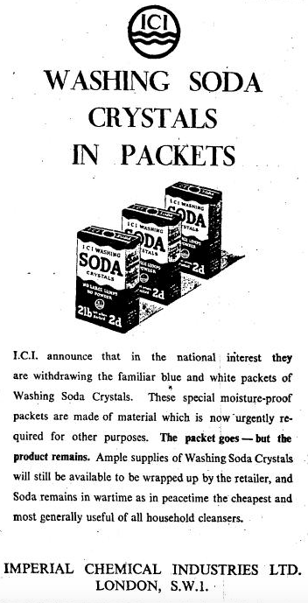

Although most of the historiography of paper rationing during WW2 focuses on the book trade because publishing was severely affected and the legacy of paper quality can be observed on shelves, and coupon fraud, packaging was also greatly affected. As indicated in the ICI advert, their packaging was functional in that it prevented the soda absorbing water. Many other products downgraded their packaging, with the card becoming thinner and poorer quality, with drab colours, often with printed explanations of this change and declaration of supporting the war effort on the packet itself. ICI appear to have thought this low quality packaging too potentially detrimental to the integrity of their product, instead choosing to forgo all branding until they could package their soda crystals as they saw best. The return of packaged soda does not seem to have been heralded by a similar advertisement, although the shelves were once more stocked with ICI's soda.

Using soda to soften water and reduce the amount of soap used was also important when soap was rationed. The development and introduction of soapless detergents discussed

Newspapers promoted other domestic uses of soda in their regular syndicated household hints columns, but soda was also beneficial in the garden. Combatting potato blight was especially important during the Grow More Food or Dig for Britain campaign, and spraying plants with washing soda mixed with copper sulphate and water could prevent it. This same anti-fungal solution was heralded by ICI as a method of stopping sand bags rotting, and the company urged people to treat their sand bags before filling them with this simple solution.

Communicating about soda
Explanations for the use of soda could occasionally be found in newspaper articles such as "Science and Housekeeping", which detailed why hard water should be softened in order to lather soap better, and that, and a weak solution of washing soda can be used to soothe sore eyes from over-chlorinated swimming pools.

However, this type of information tended to be found in the Guardian and the Daily Mail, or the Express, rather than the Times, which focussed on industrial and business reports. The Times readers did not need to know these practical points about using, as the elite audience probably had staff to do household chores for them. The most information about sodas that readers of The Times receive from the paper comes from the advertisements placed by ICI which use the household chemical to assert the worth of the chemical industry, and especially the chemical industry's place in fighting the war and making home life comfortable. These same adverts are place in other papers, which supplement the helpful household hints about using soda at home.

Selling Soda
The Boots archive shows that they sold loose washing soda until 1967, when the expense of getting loose soda delivered to their shops meant that they had to reconsider offering this option to their customers. Part of the issue was that the demand for loose soda from consumers was not enough, the shops were not shifting enough of the product to warrant the quantities that manufacturers were willing to deliver. The problem was exacerbated when in 1964, Thawpit stopped supplying Boots with soda, presumably because they closed their High Wycombe soda plant. In a letter between Boots' drug buying dept and retail prices dept, ICI 2lb packs were mentioned again, showing that this presentation endured and indicating that it was a convenient size for domestic use. Indeed, Thawpit also prepared 2lb branded packs, as did Oso. This is less than a third of the 7lbs that women before WW1 had been buying, demonstrating the move towards alternative products. Thawpit had been able to accommodate the regular small quantities called for, delivering single cwt bags within London and 5 cwts outside London, whereas ICI said that orders would not be fulfilled until there was a wagon-load ready for that destination. In 1967 ICI discontinued selling soda in anything less than 0.5 ton lots, too large an amount for the Boots shops to store for the dwindling number of customers who wanted loose soda.
Between 1930 and the 1980s, newspapers and Good Housekeeping magazine did not carry adverts for washing soda, only for more complex or dedicated preparations of cleansers and polishes. Like the newspapers, Good Housekeeping recommended the use of generic washing soda in their household hints content and associated books. Not finding adverts for washing soda suggests that manufacturers believed that this sector did not need promotion, that it was already well established and people bought whichever soda was available in their shop with little to distinguish between them, other than perhaps the size or uniformity of the crystals. This absence of print advertising indicates that this type of budgets would work harder promoting the new, complex cleaners.

Sodium bicarbonate
Sodium bicarbonate is today touted as a cleaning material that our grandmothers used; the fine white crystalline powder is gently abrasive when used as a paste on hard surfaces, it makes an alkaline solution that is not painfully caustic, it is in toothpaste so it must be safe to put in our mouths, it benignly absorbs peculiar smells in the fridge. My research shows that in Britain, baking soda was recommended as effective in a great variety of household tasks, but this is closely related to the sources interrogated. Newspapers such as the Guardian, the Daily Express and Daily Mirror which were read by the middle and working classes, included household hints featuring bicarbonate from the 1930s, most often for self medication of minor ailments or personal care uses, but also cleaning surfaces such as gilding or enamel and in caring for textiles for the removal of grass stains, iodine stainsand scorch marks. A book of household hints published in 1935 by American manufacturers of baking soda says that its uses as a general cleanser were newly discovered, but does not say when. The Manchester Guardian had published advice on using baking soda for cleaning in 1927 without commenting on this being a novel use, and while there have been no other forthcoming earlier references to using it for cleaning, the short article contained no reasoning for using the chemical other than implying that it may already be to hand.
The visibility of bicarbonate of soda or baking soda in Britain can be compared to its profile in the United States, where branded baking soda was heavily promoted in both specialist publications and the mass media. Church & Dwight, manufacturers of Arm and Hammer brand as well as Cow brand bicarbonate of soda, presented baking, stain removal, garden and garage uses in their 1935 booklet It’s in Knowing How to Use It. The booklet explains that general cleansers should be non-abrasive, soluble, dissolve oils and grease and that bicarbonate fits all these descriptions, even describing it as an emulsifier of of grease, that is safe thanks to its high purity. All the modern, new uses of baking soda beyond leavening were introduced by a smart, thrifty young housewife Mrs Anderson, who won the respect of her neighbours by having an immaculately presented home and garden due to her prowess with this simple chemical aid. Mr Anderson enlightened his uncle to the variety of uses of bicarbonate in the masculine environment of the garage, and car care, and the uncle shared a selection of farm based uses with Mrs Anderson, which were eagerly noted down, though similar to her existing home care uses based on the removal of grease. It is interesting that the couple are young, and that they both share knowledge about the multiple uses of the chemical although they may use it it in strictly gendered areas.
Church & Dwight kept bicarbonate in the public eye, and took out regular adverts in an American nursing journal to promote the medical uses of baking soda. They assured readers that either of their two brands were always at hand in the domestic environment, so could be used in general hygiene advice and for first aid. Cleaning baby bottles was the principle non-internal use listed, which implied regular, economical and gentle use, not leaving any harmful or distasteful residue for the baby. Readers were advised to send for a booklet “The Usefulness of Soda”, which used bright cartoon style graphics to present another family that uses baking soda in all their daily activities. Highly gendered, the apron-wearing wife supervised her similarly attired daughter in the variety of cleaning tasks that could be tackled with soda, while the pipe smoking father informed his son about the masculine, car-oriented uses that the chemical could be used for. Church & Dwight produced a variety of almanacs as well as recipes and household hints in which they encouraged the choice of bicarbonate of soda for various domestic uses. Promoting non-food uses of their products created a larger demand for the chemical than baking alone could do, which ensured that baking soda would be readily used up and bought. This was good for business, but also for the consumer, as baking soda can go stale and lose its effectiveness as a raising agent as it ages and absorbs moisture from the air.
These promotional booklets for baking soda seem to be uniquely American, as no equivalent appears to have been produced or distributed by British firms. The booklets are not kept by the British Library, or the Bodleian, and are not available from British second hand booksellers. This, and the lack of advertising for bicarbonate, suggests that British producers of bicarbonate of soda were not interested in increasing their sales of this product, or achieving any particular brand recognition. If we take the products on display at the Museum of Brands as evidence, baking soda simply did not appear, although multiple brands of baking powder, that is a mixture of baking soda, cream of tartar and a moisture absorbent, can be seen on their shelves. These additives appear to have more narrowly defined the purpose of the mixture to only baking, the manufactures did not replicate the promotional efforts seen in the USA. Indeed, ICI even referred to "'bicarb' for baking", almost as if it was separate to bicarb for anything else.
Although they did not extend to booklets expounding the multiple way a single chemical could be used, ICI placed a series of adverts "Services of an Industry" in the 1940s highlighting the numerous everyday products and processes that the chemical company were behind. The sodas featured regularly in these, being chemicals that ICI manufactured in vast quantities in Britain. "The hand of the chemist is found at every turn – in our washing-soda, our bicarbonate of soda, baking powder...". ICI especially linked themselves to the war efforts, "...in these days when strict economy is necessary, the careful housewife will add washing soda – crystallised sodium carbonate – to soften the water and save soap." "…the First Aider must improvise: at a pinch indeed, baking soda for scalds and burns from fire and washing soda to neutralise burns from acid." "Behind the counter, or in the inevitable shed at the back of the shop, are soda crystals (washing soda)..." linking the idealised view of the well provisioned village shop back to the war effort by saying that they provide the "farmworkers of Britain on whose labours the nation's food supply so largely depends." This series promoted ICI as the producer of chemicals that make modern life possible, rather than as the guardian of one particular product, even though they did convey educational information about domestic uses of their chemicals.
ICI were not the only purveyors of educational material about the household uses of chemical. The Ministry of Food placed newspaper adverts throughout the Second World War in the form of hints and recipes that referenced domestic uses of bicarbonate of soda, although as might be expected from their source, they mainly related to cooking. Other columns and governmentally sanctioned advice columns promoted first aid uses of the kitchen staple, but not the fire smothering capabilities of the powder. Newspapers carried occasional stories about bicarbonate of soda fire extinguishers, for instance in 1965 a large batch which had been fitted to invalid carriages were recalled due to a problem with the bracket (not any thing to do about the efficacy of the system when deployed correctly). However, the use of bicarbonate other than contained in a dedicated extinguishing device was not promoted as a method that could be used to stop small domestic fires.
After an absence of around a quarter of a century, baking soda started to be once again recommended in newspaper columns concerned with cleaning. This time, rather than enamelled hobs and baths the new consumer durables of mixed materials such as plastics, rubber such as fridges and freezers were the subject of attention.
In the 1980s crack cocaine emerged as a new drug in the US which spread quickly to Britain, and British newspaper articles went into a surprising amount of detail when discussing the use of bicarbonate of soda in the production of crack. Although not a regular domestic use, newspapers reported on the topic as if it were something that anybody could do at home, a new incarnation of kitchen chemistry. Despite the apparent fascination by the juxtaposition of an ordinary domestic substance being implicated in the homemade transformation of old fashioned cocaine into a new form of drug that articles like this expressed, this activity remained very much a specialist and minority practice. Unsurprisingly, the restriction of sodium bicarbonate because of this use was not raised in the mainstream media or in parliamentary debate. Trying to control this everyday substance because of a tiny minority of people would have not only been very difficult to do, but would have caused uproar and ridicule. However, this could be compared to citric acid, which because of its role in heroin injection was restricted, it was a much less commonly used substance, generally obtained from a pharmacy, rather than the grocery shelves and therefore not so much in the public eye. Domestic users of sodium citrate or citric acid were jam makers and home brewers, both wine and beer, where home brewing enthusiasts could go to specialist shops or mail order for supplies. Sodium citrate was suggested in domestic recipes as an alternative to fresh lemon juice, essentially meaning that it was a good substitute when lemons were scarce during WW2 for instance, but the crystalline chemical was generally unnecessary for most home uses.
Only three times was it mentioned in The Times in relation to cleaning or to stain removal: once in 1970 in relation to combating a funny smell in defrosted freezers, in a 1978 book review of Victorian clothes cleaning and the other was not a domestic use but in relation to the removal of coal tar waterproofing inside the Statue of Liberty through a specially developed kind of sandblasting, but with sodium bicarbonate. It was also connected with stains left on Liberty's face by a leak of the substance through gaps created by the removal of the coal tar.

When scouring newspapers for stories about household chemicals, another domestic situation arose for consideration. While it is not homely and does not spring to mind as a safe, protective, environment, people live in prison for considerable periods of time, performing all sorts of domestic activities there. However, these stories were of chemical misuse, though not always from the inmates. Prisoners made an escape bid using an 'ammonia spray' made from water and six bottles of 'toilet-cleaning bleach'; the mixture blinded a police dog. An example given to demonstrate the vindictiveness of prison officers was of Harpic being poured into a fish tank that had taken years to establish.

Neathercoat, E.T. "Poisons in the Home." The Daily Mail, 02 January 1926, 6.
Conran, Shirley. Superwoman : Everywoman's Book of Household Management. 2 vols London: Sidgwick and Jackson, 1975.
Nuttall, Nick. "Ici Accused of 'Green' Deception." The Times, 07 June 1990, 6.
"The Parent Company and Its Interests in the United Kingdom." edited by Imperial Chemical Industries: Catalyst, 1950.
Wilson, Charles (1970) p11
Letter from Davies, P. "Thawpit, Ici." Boots, 1964.
Wilson, Charles (1970) p11
Letter from Davies, P. "Thawpit, Ici." Boots, 1964.
"The Parent Company and Its Interests in the United Kingdom." edited by Imperial Chemical Industries: Catalyst, 1950. section 9 Who are ICI's competitors?
"Caustic Soda Works: A Warrington Plant to Close." The Manchester Guardian, 18/03/1939 1939, 8.
Terry, H. "Caustic Soda Burns: Their Prevention and Treatment." The British Medical Journal 1, no. 4302 (1943): 756-57. Terry was employed by ICI.
"Fell in Tank of Caustic Soda." The Manchester Guardian (1901-1959), 1931 Dec 24 1931, 3.
Pearn, J., J. Nixon, A. Ansford, and A. Corcoran. "Accidental Poisoning in Childhood : Five Year Urban Population Study with 15 Year Analysis of Fatality." British Medical Journal 288, no. 6410 (1984): 44-46.
Miss Leslie's Magazine, quoted in Crinolines and Crimping Irons p 32
Craig, J. O. "Emergencies in General Practice: Poisons Children Swallow." The British Medical Journal 2, no. 4954 (1955): 1496-98.
Fraser, Neil C. "Accidental Poisoning Deaths in British Children 1958-77." The British Medical Journal 280, no. 6231 (1980): 1595-98.
"Ten Calls for Ambulance: Bolton's Bad Night." The Manchester Guardian, 04/08/1937.
"The Monster: A Kitchen Transformation." The Manchester Guardian, 02/11/1932 1932.
"Old Furniture: Stripping and Renovating" The Manchester Guardian, 04/09/1935 6.
"Winter Spraying: Fruit and Other Trees." The Manchester Guardian, 30/11/1940 1940.
Duckham, Alexander. "Removing Stumps of Oaks." The Times (28/07/1930 1930): 18.
"The Manchester Assizes: A Lover's "Brutal Revenge"." The Manchester Guardian, 24/04/1940 1940, 10.
Trace, T. "Personal View." The British Medical Journal 2, no. 6090 (1977): 825.
"Control and Sale of Poisons." The Manchester Guardian, 02/12/1935 1935.
Reeves p61
Reeves, Pember. Round About a Pound a Week. The English Working Class. New York: Garland Pub., 1980. (p60)
Reeves p61
"Shoes at the Seaside." The Manchester Guardian, 07/08/1934 p6
Dixon, Joan, and Kathleen E. Fletcher. 3rd ed. London: Pitman, 1974.
Richardson, G.D. "Harpic Formula." 2: History of Advertising Trust, 1966. HAT 50/1/147/3/2/7
Reckitt, Basil N. The History of Reckitt and Sons Limited. London and Hull: A Brown and Sons Limited, 1951.
JWT 5/9/1, HAT Archive.
Letter from JWT to Reckitt & Sons 27 August 1937, JWT 5/9/1
Fanshawe, Simon. "Grouchy Harpic and Cha-Cha... And Me." The Guardian, 29 August 1990, 32.
Downing, Beryl. "Experts Expound on the Proof of Puddings." The Times, 10 December 1983, 15.
Daniel, John. "Chateau Oz Comes of Age." The Guardian, Mar 25 1989, 11.
Nye, Robert. "A Literary Goldmine Behind the Men's Socks." The Times, 10 July 1970, 8.
Cowe, Roger. "Mustard Men Turn Hot-Foot to Their Strongest Tradition." The Guardian (1959-2003), 1988 Apr 08 1988, 16.
Reckitt & Colman, "Market Research Officer." The Observer, 11 October 1964, 17.
Reckitt & Colman, "Market Research Supervisor." The Guardian, 12 November 1968, 11.
Reckitt & Colman, "Market Research Officer." The Observer, 11 October 1964, 17.
Buchan, Ursula. A Green and Pleasant Land: How England's Gardeners Fought the Second World War. London: Hutchinson, 2013.
"An Antirrhinum Menace: How Gardeners Should Combat It." The Manchester Guardian, 21/03/1936 1936.
"Dandelions." The Manchester Guardian, 01/07/1936 1936.
"The Monster: A Kitchen Transformation." The Manchester Guardian, 02/11/1932 1932.
"Infested New Houses: Salford's Measures National Campaign Possible." The Manchester Guardian, 12/12/1933.
"Science and Housekeeping: Some Small Points." The Manchester Guardian, 27/08/1935 1935
"Science and Housekeeping: Some Small Points." The Manchester Guardian, 27/08/1935 1935.
First Aid No 34 in the "Services of an Industry" series, ICI, 1943
First Aid No 34 in the "Services of an Industry" series, ICI, 1943
"Mantlepiece Stains." The Manchester Guardian, 08/11/1934 1934.
"Imperial Chemical Industries." The Times, 17/10/1940 1940, 3.
"Imperial Chemical Industries." The Times, 17/10/1940 1940, 3.
Examination of displays at the Museum of Brands.
"Two Potato Diseases." The Manchester Guardian, 22/03/1941 1941.
"Imperial Chemical Industries Limited." The Times, 27/06/1941 1941, 3.
"Science and Housekeeping: Some Small Points." The Manchester Guardian, 27/08/1935 1935.
"To Clean Gilding." The Manchester Guardian, 20 Apr 1927, 6.
"Spring Cleaning: The Bathroom." The Manchester Guardian, 15 May 1935, 6.
"Grass Stains." The Manchester Guardian, 1933 Sep 14 1933, 6.
"Iodine Stains." The Manchester Guardian, 1933 Jul 10 1933, 6.
"Scorch Marks." The Manchester Guardian, 1934 Feb 22 1934, 6.
Church &Dwight. It's All in Knowing How. USA: Church & Dwight, 1935. inner cover
"To Clean Gilding." The Manchester Guardian, 20 Apr 1927, 6.
Church &Dwight. It's All in Knowing How. USA: Church & Dwight, 1935. p27
Emporium in Arcady No. 37 in the "Services of an Industry" series, ICI, 1944
The Kitchen Front No. 12 in the "Services of an Industry" series, ICI, 1942
Ruffs and Cuffs No. 36 in the "Services of an Industry" series, ICI, 1943
First Aid No 34 in the "Services of an Industry" series, ICI, 1943
Emporium in Arcady No 37 "Services of an Industry" series, ICI, 1944
"Recall of 4,000 New Extinguishers." The Times, Jun 27 1965, 5.
Hilary, Gelson. "Cool Calm and Collected." The Times (09/07/1970 1970): 8
Longmuir, Harry, and Keith Colling. "Jail-Break Men Made Their Own Arsenal." The Daily Mail, 28 November 1972, 9.
Sale, Jonathan. "Inside Story of Life Behind Bars." The Times, 27 October 1973, 14.

